34.47: a) 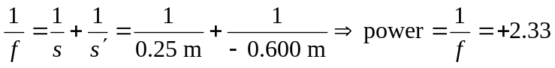 diopters.
b) 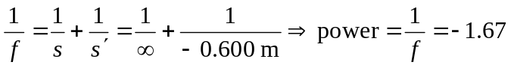 diopters.

